
caCORE SDK 3.0.1
CSM Enabling of SDK and Writable APIs for SDK

Version No: 1.2
Last Modified: 07/12/2005

Author : Vinay Kumar
Team : Common Security Module (CSM)
Purchase Order# 34552
Client : National Cancer Institute - Center for Bioinformatics,
National Institutes of Health,
US Department of Health and Human Services

Document History

Document Location
The most current version of this document is located in CVS under security/docs.

Revision History
Version Number | Revision Date | Author | Summary of Changes
0.1 |  | Vinay Kumar | Initial draft
1.0 | 5/17/05 | Eric Copen, Satish Patel | Text changes and formatting
1.1 | 07/08/05 | Vinay Kumar | Additional diagrams and content
1.2 | 07/12/05 | Eric Copen | Grammatical changes

Review
Name | Team/Role | Version | Date Reviewed | Reviewer Comments
Satish Patel | caMatch/Developer | 0.1 | 5/17/05
Eric Copen | QA/Developer | 0.1, 1.0 | 05/13/05, 5/17/05
Eric Copen | QA/Developer | 1.1 | 07/12/05

Related Documents
More information can be found in the following related CSM documents:

Document Name

Table of Contents
1. Introduction 4
1.1 Purpose 4
1.2 Definitions, Acronyms, and Abbreviations 4
2. caCORE SDK 4
2.1 Background 4
2.2 Problem Scenario 5
3. Front Controller Pattern 5
4. HTTP Remoting 6
5. Application Service 6
6. CSM Integration 8
7. Session Management 10
8. Step Toward Writeable APIs and Transaction Management 11
8.1 Simple Writable APIs 12
9. Code Generation 14
10. Class Diagram 14
11. Putting It All Together 15
12. Components 17
13. Environment 17
14. In Scope 17
15. Out of Scope 17

Introduction
caCORE SDK follows the Model Driven Architecture (MDA) approach. It automatically generates a set of APIs from the model defined in UML. This design document highlights some of the enhancements that will be introduced in SDK to make it more usable.

Purpose
The purpose of this document is to propose the design solution to introduce the writable APIs with CSM enabling and session management to SDK.

Definitions, Acronyms, and Abbreviations
- AOP – Aspect Oriented Programming
- CSM – Common Security Module
- SDK – Software Development Kit
- API – Application Programming Interface
- EA – Enterprise Architect, a tool for UML modeling
- MVC – Model-View-Controller, a design pattern
- BO – Business Object

caCORE SDK

Background

Currently the caCORE SDK generates the set of APIs for the server and client side. The server side APIs run behind a HTTP server which has a proxy interface for querying the data. The proxy interface contains only one method called “query”.
The “query” method takes a request as a parameter and sends the response with the result of the query.

Request
Response
HTTP Server

API.jar
Client

Figure 1 Existing Architecture

Problem Scenario
The present architecture supports only one method though a proxy interface, however more methods can be introduced. Therefore, the interface definition has to change. There might be different types of business requests sent to the HTTP server. Depending upon the type of business request, there could be number of methods introduced in the proxy interface. These methods can be processed by either implementing a number of “if/else” statements or by using a command pattern for handling these requests. Our solution proposes the command pattern as described in the following section.
Additional avenues for improvement include:
- At present the exposed service is not security aware.
- There is no access control.
- There is a need to secure the resources and the data..
- One should be able to plug in different credential providers for authentication.
- For data access control there should be a mechanism for authorization policy.
There is way to maintain a session for user at the server side, which may require the user to authenticate at every request. This may result into poor performance.

Front Controller Pattern

There is a Front Controller Pattern that can solve these kinds of problems. Please see Figure 2.2 below:

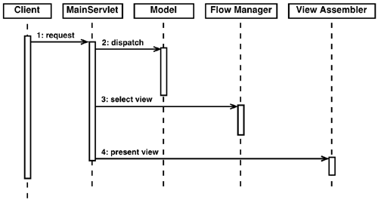
Figure 2 Front Controller Pattern

There are two ways to implement the Front Controller Pattern. The first option is to create a self-developed implementation of this pattern. The advantage is no dependence on an external framework. The second, preferred option is to use an existing framework that provides the necessary capability with distributing computing. The Spring Framework provides all these capabilities out of the box. It is fairly simple to expose any Application Service layer with Spring remoting as the HTTP service.

HTTP Remoting
Exposing the Application Service interface as an HTTP service is performed by the utilization of both the HTTPClient project from Apache and the dependency injection functionality of the Spring Framework. Since code will be auto-generated based on the Application Service interface, developers will not need to know details regarding the HTTPClient or the Spring Framework. However, a brief overview of the two products and the specific functionalities utilized to generate the Writeable APIs is provided in the following two paragraphs.
HTTPClient is an open-source project that provides very rich APIs to manage the HTTP protocol from the client side. It offers flexibility and functionality beyond the needs of CSM Enabled SDK, and its extendibility may prove useful in the future. An introduction to HTTPClient can be found at http://jakarta.apache.org/commons/httpclient/.
The Spring Framework provides an additional level of abstraction and hides complexity. The Dependency injection model has been very well addressed by Spring Framework. Using these tools allows a developer to plug in different implementations if needed without changing the code. For further information on Spring Framework please visit www.springframework.org.

Application Service
Since the user’s focus is on using the Application Service, the complexity for managing security and session management will be taken care by underlying layer, which is completely hidden from user. All these layers are generated by the code generation piece. The Application service layer is the core of the whole approach. The generated code depends on the Application service interface. The Application service interface is the interface where writable methods for the domain objects are defined. In the same interface one can add additional business methods. This Application service interface can then be exposed as an HTTP service using the code generation piece. To make it a HTTP service, use of Spring HTTP remoting has been made. The following class diagram will be helpful in understanding the solution:
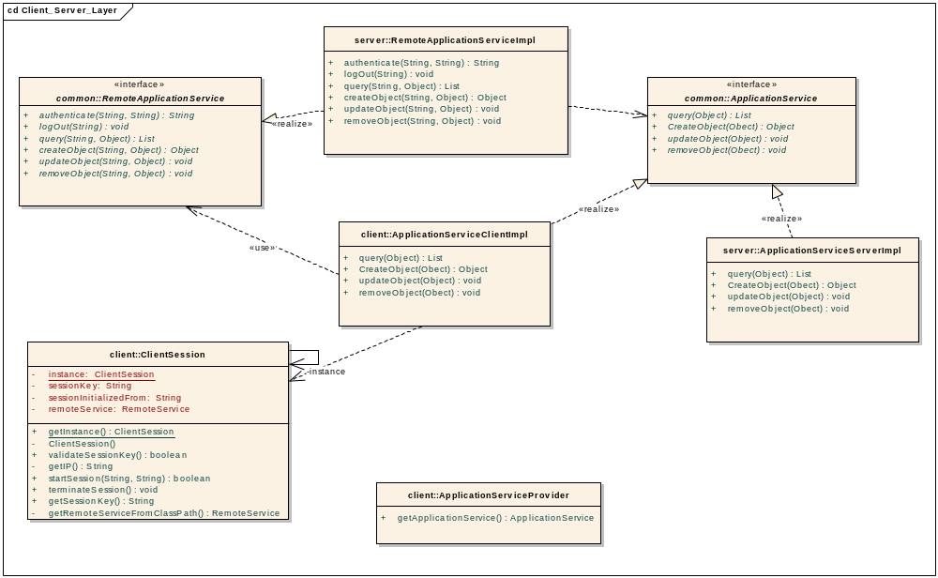
Figure 3 Class Diagram

The above diagram is based on Application Service called ApplicationService interface. The diagram shows that there are two implementations of the ApplicationService interface, one for the client and one for the server. Whenever a client tries to get a handle to the ApplicationService, it gets handle to the implementation on the client side. But the client side implementation in turn uses RemoteApplicationService, which is a generated interface with its implementation. This way whenever a client makes a call to any method on the service, the call is delegated to the RemoteApplicationService, which in turn obtains the session Key for that user and sends it to the server. So RemoteApplicationService proxies for the user call with the session key embedded in every call. This way the user does not have to authenticate with every request.

The RemoteApplicationServiceImpl is also generated class. This object will intercept any call to the ApplicationService interface before it is executed. The sequence diagram below is for illustration purposes only. The user will never make a direct call to this class but this is how it works.
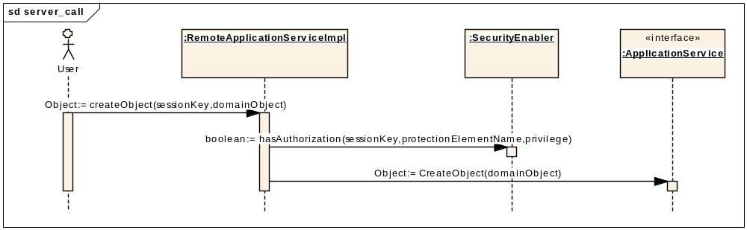
Figure 4 A Call to the ApplicationService Interface
This is a simple diagram showing the role of the RemoteApplicationServiceImpl class. For further clarifications, refer to the EA Model that contains a larger sequence diagram with all “if else then” conditions. In this diagram that RemoteApplicationServiceImpl clsss intercepts the call and then makes the decision to call that method or not based on the authorization result from SecurityEnabler .

CSM Integration
CSM integration with Application Service is crucial to protect the data and the resources. The CSM integration will be achieved with the SecurityEnabler class. SecurityEnabler is a wrapper for the CSM Authentication and Authorization mangers. It works in conjunction with the SessionManager class, which keeps track of the user sessions. When a user logs in successfully a session key is generated for that user and the user session is kept with SessionManager. All the subsequent calls can be made with the session key. There is no need to authenticate for every call. SecurityEnabler obtains the user object from SessionManager and checks for authorization on a protection element, which may be an operation or a domain object.

Figure 5 is the part of the sequence diagram showing the process for authentication and user session initialization.
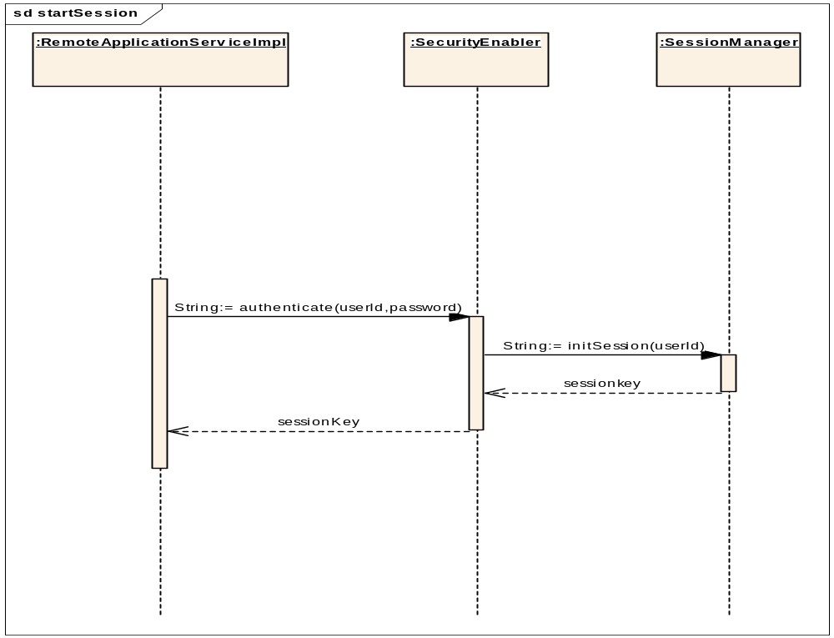
Figure 5 Authentication and user session initialization

Figure 6, a class diagram, shows the classes involved in the above sequence diagram.

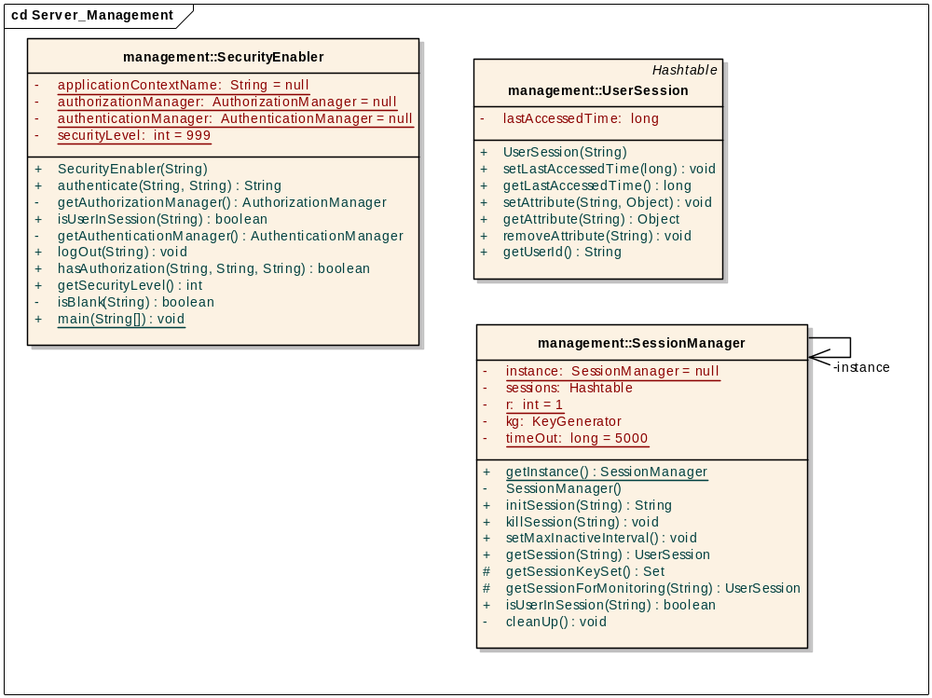
Figure 6 Classes involved with authentication and user session initialization

Privileges on protection elements (operations and domain objects) can be granted using the User Provisioning Tool (UPT). The authorization policy for each application is driven by the authorization schema data accessed by the UPT. For details regarding the UPT, refer to the UPT User’s Guide.
CSM integration does not require any coding on the part of the developers. The code generation piece generates all the code needed for security for an Application Service layer.
The authorization mechanism in reflected in Figure 3.

Session Management
User session management is important for the reason that the users will not have to authenticate again and again for every request. Session management is achieved with the SessionManager class, along with other helper objects that work together with SessionManager.

It will be worthwhile to review the session management class diagram in Figure 7.
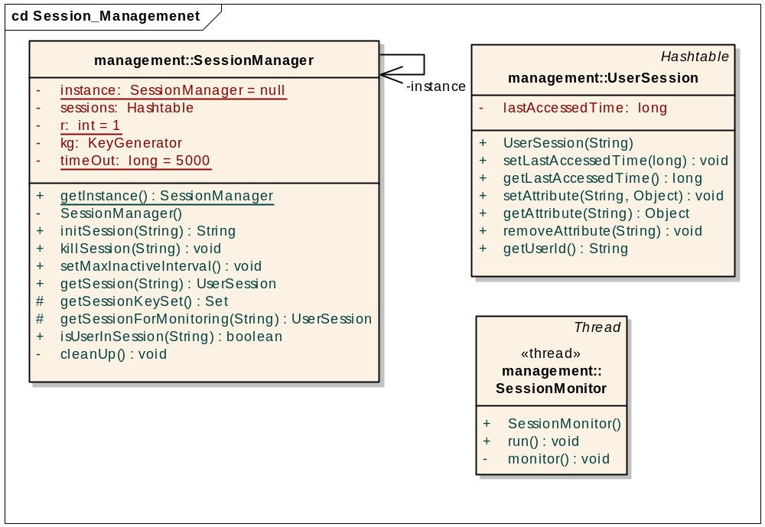
Figure 7 Class diagram for session management

SessionManager initializes the UserSession object after successful login into the service. The UserSession objects are stored in the sessions within SessionManager. The session time out can be configured using a configuration file discussed in the SDK Programmers Guide. Once the session times out the user has to authenticate again. There is a thread called SessionMonitor, which is fired if the number of sessions exceeds a threshold set in a configuration file. The SessionMonitor Object cleans up all the inactive sessions from session pool.

Step Toward Writeable APIs and Transaction Management
At present, SDK generates query-only APIs for objects defined in the UML model. Writing to the persistence layer is one of the requirements that have arisen. The domain model is generated as POJO (Plain old java objects) or Java beans, which are not transaction aware. Handling the pure POJOs is easier for developers, however while persisting them, transaction management can prove a difficult challenge. Hibernate provides a wrapper around transaction management APIs but it might require coding from the developer. For generated code from SDK, we want to stay away from programmatic transaction management. The declarative transaction management is the preferred approach. One of the options to tackle this problem is to use Spring Framework, which provides a transaction management abstraction layer. By using Spring, in the future a different underlying transaction management can be used by simply changing the configuration file.

Simple Writable APIs
The first step toward writable APIs and Transaction Management is creating a simple writable API, which performs simple CRUD operations. These CRUD operations will be exposed as a Persistence Manager service layer or any other business service. The idea behind this is to enable distributed computing.
public interface SDKApplicationService {

public Object createObject(Object obj) throws ApplicationException;

public Object updateObject(Object obj) throws ApplicationException;

public void removeObject(Object obj) throws ApplicationException;

public List getObjects(Object obj) throws ApplicationException;

}

Figure 8 Application Service methods used for CRUD operations
The above interface shows the methods that can be used to perform the CRUD operations. There is a default implementation provided with a solution for persistence. That implementation can be used to implement this interface. Developers can choose to use any other implementation as well.
Figure 9 shows the HibernateDAO class used for persistence.
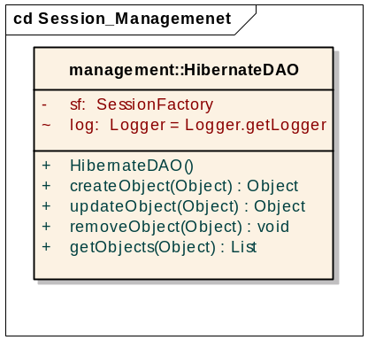
Figure 9 The HibernateDAO class used for persistence
The following diagram (Figure 10) shows how a typical CRUD operation will be executed. This diagram’s text size is reduced so that it fits in this document. This diagram can be read if you zoom in.
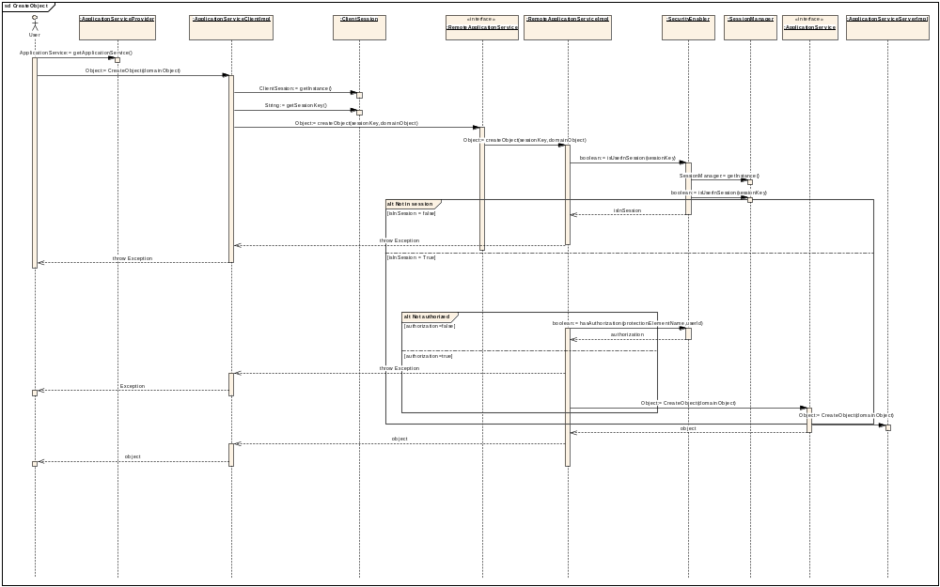
Figure 10 CRUD operation execution

Code Generation
The code generation component generates the code which is needed it to make Application Service a fully functional service with security, session management and writable APIs. The code generation component works on the Application Service interface provided to it. Code generation component makes use of the generated code from the SDK toolkit, Spring Framework, and the Application Service interface. A detailed description of the code generation design is beyond the scope of this document.

Class Diagram
This complete class diagram shows the different objects that participate in HTTP service.
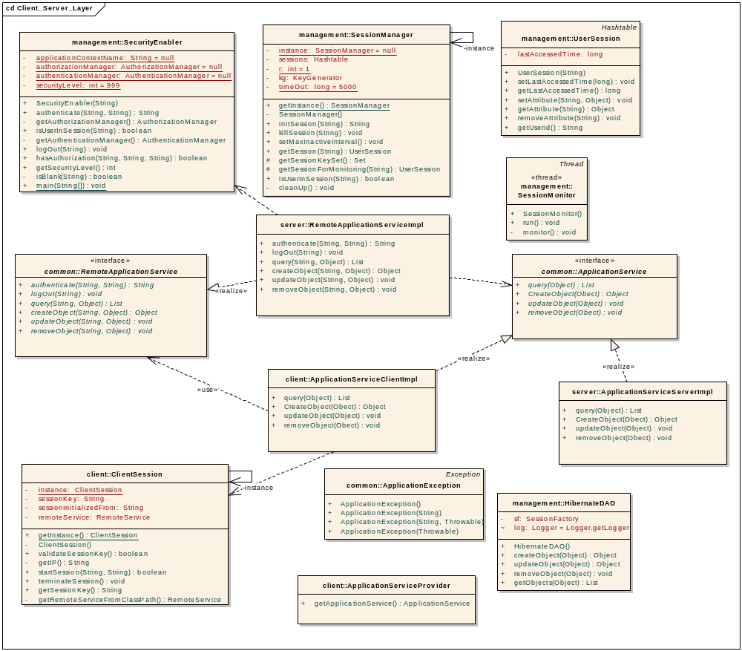
Figure 11 Complete class diagram

Putting It All Together

caCORE SDK will generate the APIs from the model definition in XMI format. The generated APIs will consist of the following:
- Domain Objects
- Server-Side APIs
- Service Layer (may or may not be there)
- DAO Layer
- All configuration files
Once you have all these artifacts from the SDK toolkit, you can define an Application Service interface defining all the methods that you want to expose. The code generation component will use the Application Service interface to generate the client and server code and export the Application Service as a HTTP service.

Currently the service is exposed through a proxy interface using HTTP tunneling, which limits the client to be only a java-based HTTP client. Ideally the server-side application should be accessible by clients that use RMI, HTTP, or Web Service protocol. Depending upon the system requirement, one should be able to choose the preferred client. However, the nature of client should not affect the server-side application.
BO
BO
S
E
R
V
I
C
E

L
A
Y
E
R
RMI
CLIENT
HTTP CLIENT
WEB SERVICE
CLIENT
WEB CLIENT
LOCAL JAVA CLIENT

Domain objects

B
U
S
I
N
E
S
S

DELEGATE

S
ECUR
I
T
Y

L
A
Y
E
R

D
A
O

L
A
Y
E
R

Figure 12 Distributed Computing with different clients

The Security layer proposed here is security level 1 only.

Although we propose to support different types of clients, for the current release we would limit to HTTP Client only. Spring Framework, which uses HTTPClient, will be used for remoting. Please see the diagram below:

SERVICE INTERFACE
SERVICE INTERFACE
SPRING Remoting
HTTP INVOKER LAYER
HTTPSERVICE EXPORTER
HTTPClient Layer

Client Web Server Figure 13 HTTP Remoting

Components
The following diagram shows the different components involved in the architecture:

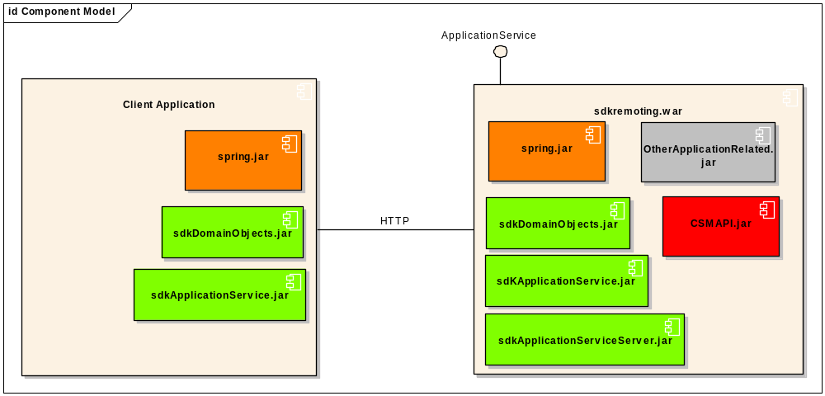
Figure 14 Final Deployment Diagram

Environment
Following is the list of the environment components required for this architecture:
- JDK 1.4.2.x
- JBoss 4.x
- EA 4.5
- Spring 1.2
- HTTPClient 3.0

In Scope
- HTTPClient will be provided to access service interface
- CSM will be integrated for method level only (level 1 or level 0)
- Write API will be provided
- Session Management will be provided

Out of Scope
- AOP integration will not be provided in this release (No Aspects)
- RMI Client will not be provided
- Web services Client will not be provided

